Pharmacy Clinical Trials – Dispensing Error Reporting Log and Codes

(This form should be used in conjunction with Pharm/S87 – Recording and monitoring of dispensing errors in clinical trials)

IT IS THE RESPONSIBILITY OF ALL USERS OF THIS SOP TO ENSURE THAT THE CORRECT VERSION IS BEING USED

All staff should regularly check the R&D Unit’s website and/or Q-Pulse for information relating to the implementation of new or revised versions. Staff must ensure that they are adequately trained in the new procedure and must make sure that all copies of superseded versions are promptly withdrawn from use unless notified otherwise by the SOP Controller.

The definitive versions of all R&D Unit SOPs appear online. If you are reading this in printed form check that the version number and date below is the most recent one as shown on the R&D Unit website: https://www.research.yorkhospitals.nhs.uk/sops-and-guidance-/ and/or Q-Pulse

SOP Reference: | Pharm/F29
Version Number: | 3.0
Author: | Courtney Cole
Implementation date of current version: | 5th January 2021

Approved by: | Name/Position: | Poppy Cottrell-Howe
Approved by: | Signature: | 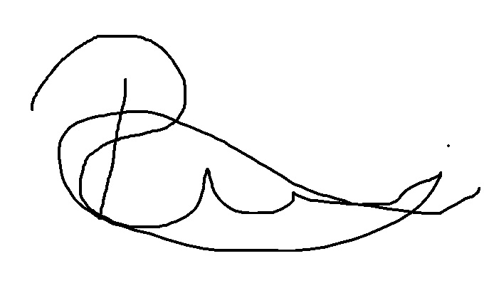
Approved by: | Date: | 8th December 2020
 | Name/Position: | Sarah Sheath, SOP Controller
 | Signature:
 | Date: | 8th December 2020

This SOP will normally be reviewed every 3 years unless changes to the legislation require otherwise

Version History Log

This area should detail the version history for this document. It should detail the key elements of the changes to the versions.

Version | Date Implemented | Details of significant changes
1.0 | 20th August 2015
2.0 | 21st December 2017 | Change of author and merger of error codes (Pharm/F30)
3.0 | 5th January 2021 | Change of Author

Time | Rx Type | Error Code | Escaped  (Yes/No) | Name of trial | Details of error | Dispenser’s  full name | Checker’s  full name | Feedback given  (Yes/No) | Feedback received (Signature)
16.00 | CCP | 5 | No | Myeloma XI | Lenalidomide directions on label indicate 20 day course when it should be taken for 21 days. | Joe Bloggs | John Smith | Yes | Joe Bloggs

Prescription Codes (Rx)
CTP | Clinical Trial Prescriptions
CCP | ChemoCare Prescriptions

Error Codes ( * minor errors)
1. Incorrect drug/kit no./ bottle no. | 11. Incorrect quantity
2. Incorrect strength/dose | 12. Incorrect cost centre *
3. Incorrect form | 13. Missing item(s) from Rx
4. Incorrect patient name and/or trial number | 14. Missing signature *
5. Incorrect directions | 15. Missing supplementary items *
6. Correct drug/kit no./bottle no., incorrect label | 16. Incorrect calculation
7. Incorrect drug/kit no./bottle no., correct label | 17. Missing accountability log/s or incorrect completion
8. Patient allergy status missing  (NB. Rx should not be dispensed without an allergy status) | 18. Incomplete or incorrect completion of ‘For Pharmacy use’ section
9. Missing additional warning/s | 19. Prescriber not on the delegation log (NB. Rx must not be dispensed if the prescriber is not on the delegation log)
10. Expiry – missing, incorrect or expired stock | 20. Other

