Daily Clinical Trials Temperature Checks
This form is to be used in conjunction with SOP Pharm/S48 – Temperature Monitoring (Clinical Trials)

IT IS THE RESPONSIBILITY OF ALL USERS OF THIS SOP TO ENSURE THAT THE CORRECT VERSION IS BEING USED

All staff should regularly check the R&D Unit’s website and/or Q-Pulse for information relating to the implementation of new or revised versions. Staff must ensure that they are adequately trained in the new procedure and must make sure that all copies of superseded versions are promptly withdrawn from use unless notified otherwise by the SOP Controller.

The definitive versions of all R&D Unit SOPs appear online. If you are reading this in printed form check that the version number and date below is the most recent one as shown on the R&D Unit website: https://www.research.yorkhospitals.nhs.uk/sops-and-guidance-/ and/or Q-Pulse

SOP Reference: | Pharm/F108
Version Number: | 3.0
Author: | Rachel Spooner
Implementation date of current version: | 22nd February 2021

Approved by: | Name/Position: | Poppy Cottrell-Howe, Pharmacy Clinical Trials Manager
Approved by: | Signature: | 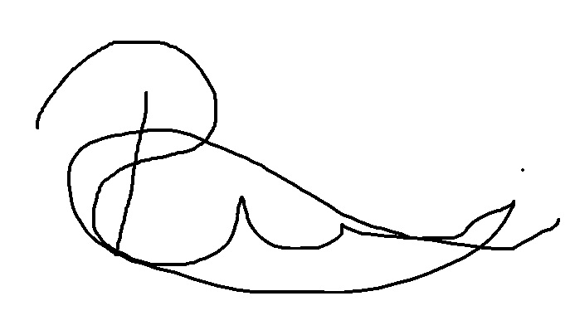
Approved by: | Date: | 21st January 2021
 | Name/Position: | Sarah Sheath, SOP Controller
 | Signature:
 | Date: | 25th January 2021

This SOP will normally be reviewed every 3 years unless changes to the legislation require otherwise

Version History Log

This area should detail the version history for this document. It should detail the key elements of the changes to the versions.

Version | Date Implemented | Details of significant changes
1.0 | 19th October 2015
2.0 | 5th February 2018 | Change of form design
3.0 | 22nd February 2021 | Change of link to R&D website. Change of author.

Daily Clinical Trials Temperature Checks

Location ………………………………………… Month/Year ……………………………
Temp range (delete as applicable) Fridge 2-8°C /Ambient 15-25°C /Freezer -10- -20°C / other……....

Date | Temp Checked By | Time | Min  °C | Max  °C | Average °C | Temp excursion  Y / N | Action
1st
2nd
3rd
4th
5th
6th
7th
8th
9th
10th
11th
12th
13th
14th
15th
16th
17th
18th
19th
20th
21st
22nd
23rd
24th
25th
26th
27th
28th
29th
30th
31st

Forward completed logs to the clinical trials manager or delegate at the end of each month for authorisation prior to filing.

Pharmacy Manager/Delegate (signature) ……………………………. Date ……………………….

