Receipt and Review of Amendments in Pharmacy Form
(to be used in conjunction with Pharm/S79 – Receipt and review of amendments in Pharmacy)

IT IS THE RESPONSIBILITY OF ALL USERS OF THIS SOP TO ENSURE THAT THE CORRECT VERSION IS BEING USED

All staff should regularly check the R&D Unit’s website and/or Q-Pulse for information relating to the implementation of new or revised versions. Staff must ensure that they are adequately trained in the new procedure and must make sure that all copies of superseded versions are promptly withdrawn from use unless notified otherwise by the SOP Controller.

The definitive versions of all R&D Unit SOPs appear online. If you are reading this in printed form check that the version number and date below is the most recent one as shown on the R&D Unit website: https://www.research.yorkhospitals.nhs.uk/sops-and-guidance-/ and/or Q-Pulse

SOP Reference: | Pharm/F94
Version Number: | 4.0
Author: | Cheryl Donne
Implementation date of current version: | 25th February 2021

Approved by: | Name/Position: | Poppy Cottrell-Howe, Pharmacy Clinical Trials Manager
Approved by: | Signature: | 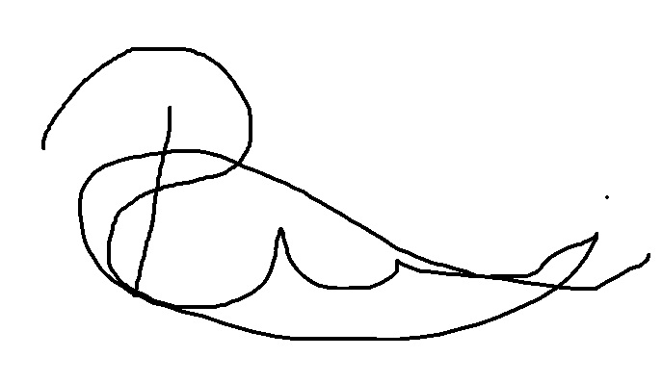
Approved by: | Date: | 8th January 2021
 | Name/Position: | Sarah Sheath, SOP Controller
 | Signature:
 | Date: | 28th January 2021

This SOP will normally be reviewed every 3 years unless changes to the legislation require otherwise

Version History Log

This area should detail the version history for this document. It should detail the key elements of the changes to the versions.

Version | Date Implemented | Details of significant changes
1.0 | 22nd November 2013 | Section included to document that the Principal Pharmacist, Clinical Trials and Research (or delegated responsible Pharmacist) has to be informed of amendment.
2.0 | 19th January 2015
3.0 | 24th May 2018 | Change of author. Form changed to include the 4 stages of processing amendments.
4.0 | 25th February 2021 | Change of link to R&D website. Change of author. Reformatting of form, removal of sending emails to R&D members as not required.

Pharmacy Clinical Trial Amendment Form
Short Trial Name/Number
EudraCT Number
R&D Reference
Sponsor
PI
CTA or Research Nurse dealing with this amendment
Site
Date of notification of the amendment
Amendment Number
Speciality and Indication
Date added to amendment tracker spreadsheet

General overview of amendment:

Attach the summary of changes to the back of this form if received

1. Pharmacy feasibility
This stage must be completed within 35 days of receipt of amendment; this does not mean it has to be implemented in this time scale
Amendment received from whom
and their job title if applicable
35 days from receipt of amendment
into the Trust
HRA categorisation  (please tick)
  A | B | C
  An amendment to a research study that ALL participating NHS  Organisations are expected to consider. | An amendment to a research study that only those participating NHS  Organisation affected by the amendment are expected to consider. | An amendment to a research study that participating NHS  Organisations are not expected to consider.
  ❑ | ❑ | ❑
Amendment type (please tick) | Substantial  Non-substantial 
Approvals | Date of HRA approval:  Date of Ethics approval:  Date of MHRA (only for Substantial) approval:
Documents received  Save all documents in the relevant electronic folder on the x:drive for the specific study
  Type of document | Should it be printed | Tick if received
  Protocol | Yes | ❑
  Protocol with tracked changes | No | ❑
  IB | Yes | ❑
  SmPC | Yes | ❑
  Summary of Changes | Yes | ❑
  Any other pharmacy related documents e.g. accountability logs and prescriptions | Yes | ❑
  Non pharmacy related documents e.g. patient questionnaires | No | ❑
Do any other departments within pharmacy need to be involved?  (if the amendment affects satellite/aseptic i.e. changes to ChemoCare charts /worksheets please seek approval before completing this stage) | Yes  No  Details:
Any additional costs to pharmacy | Yes  No If yes please state

Is pharmacy happy to proceed with this amendment at this stage with the documentation, information we have been provided with at this time Yes/No (circle)

Completed by: Print ………………………………………… Sign………………………………………… Date……………………

Pharmacist signature (if required for drug or clinical treatment related amendments) Sign……………………………… Date………………

Pharmacy No-Objections / Objection (delete as appropriate) email sent to Research Governance and named member of research staff/CTA.
Sent by……………………………………………….. Date sent…………………… Attach copy of email to the back of this form.
2. Pharmacy Review of changes required
Pharmacy cannot agree an implementation date with the relevant parties until the below is completed.

Date of capability and capacity received from R&D
Are there any changes that need to be made or considered within pharmacy in relation to this amendment? | Yes  No
Documents which require amendment
  Documents to amend | Y/N | Date amended
  Trial instructions
  Labels
  Prescription / ChemoCare charts
  Pharmacy site file spine/front cover labels
  Accountability logs
  Contact sheets
  Study specific SOP
  Aseptic worksheets & labels
Is additional Sponsor training required | Yes  No
Pharmacy support departments completion of changes, if applicable  Attach e-mail confirmation to this form if not signed. | Sign:  Print:  Date:

Completed by: Print …………………………………………. Sign……………………………………. Date……………………

3. Readiness - Planning for Implementation
Date on which the in house pharmacy training log has been signed by all required pharmacy personnel
Date on which sponsor training completed by all required pharmacy personnel
(if required)
Date on which all amended documents reviewed and approved
Agreed implementation date
Name and job title of the research member agreeing the implementation date

Completed by: Print ……………………………….. Sign……………………………….. Date……………………

4. Implementation
Actual date of implementation
Date new documents filed in their relevant section of the Pharmacy Site File
Amendment log updated in the pharmacy site file (found in section 21) | ❑ Tick when complete
Date old documents superseded
Inform pharmacy support departments that we are working to new version | ❑ Tick when complete
Amendment tracker spreadsheet and white board updated | ❑ Tick when complete

Completed by: Print ……………………………….. Sign……………………………….. Date……………………

