Pharmacy Invoice Template
(to be used in conjunction with Pharm/S42)

IT IS THE RESPONSIBILITY OF ALL USERS OF THIS TEMPLATE TO ENSURE THAT THE CORRECT VERSION IS BEING USED

All staff should regularly check the R&D Unit’s website and/or Q-Pulse for information relating to the implementation of new or revised versions. Staff must ensure that they are adequately trained in the new procedure and must make sure that all copies of superseded versions are promptly withdrawn from use unless notified otherwise by the SOP Controller.

The definitive versions of all R&D Unit SOPs appear online. If you are reading this in printed form check that the version number and date below is the most recent one as shown on the R&D Unit website: https://www.research.yorkhospitals.nhs.uk/sops-and-guidance-/ and/or Q-Pulse

Template Reference: | Pharm/T14
Version Number: | 5.0
Author: | Rachel Spooner
Implementation date of current version: | 15th March 2021

Approved by: | Name/Position: | Poppy Cottrell-Howe, Pharmacy Clinical Trials Manager
Approved by: | Signature: | 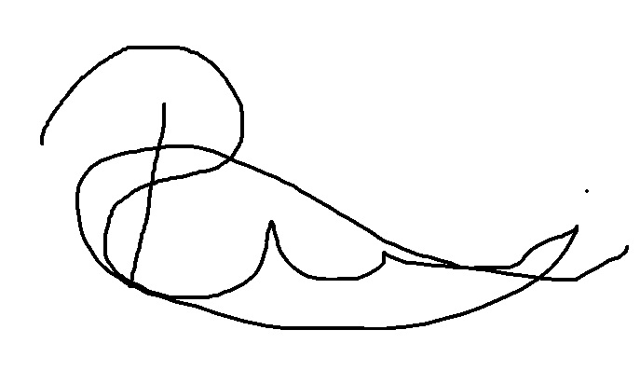
Approved by: | Date: | 17th February 2021
 | Name/Position: | Sarah Sheath, SOP Controller
 | Signature:
 | Date: | 19th February 2021

This Form will normally be reviewed every 3 years unless changes to the legislation require otherwise

Version History Log

This area should detail the version history for this document. It should detail the key elements of the changes to the versions.

Version | Date Implemented | Details of significant changes
1.0 | 1st January 2010
2.0 | 4th February 2013 | Change of SOP Controller. Removal of references to the North and East Yorkshire R&D Unit
3.0 | 12th April 2015 | Removal of additional spreadsheet as no longer required. Captured additional information on template; Principal Investigator, Protocol, Site, EudraCT and R&D numbers. Also added section to include a full description of the fees being requested.
4.0 | 18th June 2018 | Change of author. No other changes necessary
5.0 | 15th March 2021 | Change of author. Change of link to R&D website. No Changes required.



INVOICE REQUEST

Dear

Could you please raise the following invoice relating to the study.

The income is to be credited to Pharmacy Research (112526) and to VAT.

Please ensure that the following are quoted on the invoice:

PI :
Protocol No:
Site Number :
EudraCT No:
R&D Ref:

Thanks

DD / MMM / YYYY
Payee name:

Payee Address:

For the attention of:

Fees:
Set-up/Close-down/IMP Dispense/Trial Maintenance/Storage/Aseptic Compounding/Medicine Reconciliation/Waste Disposal/Other (delete as appropriate)
Full Description e.g. Patient Number and dispensing visits, maintenance fees including months
£
VAT: £ @20%

Total: £

Payment Reference: YOR- C0 - Study Name - Pharmacy – MMM/YYYY

Budget Codes: £ RCBN/ 112526 / 455500/ 0000/ 0000
£ VAT

