Trial Specific Pharmacy Monitoring Visit Form Template

This form is to be used in conjunction with SOP Pharm/S76

IT IS THE RESPONSIBILITY OF ALL USERS OF THIS FORM TO ENSURE THAT THE CORRECT VERSION IS BEING USED

All staff should regularly check the R&D Unit’s website and/or Q-Pulse for information relating to the implementation of new or revised versions. Staff must ensure that they are adequately trained in the new procedure and must make sure that all copies of superseded versions are promptly withdrawn from use unless notified otherwise by the SOP Controller.

The definitive versions of all R&D Unit SOPs appear online. If you are reading this in printed form check that the version number and date below is the most recent one as shown on the R&D Unit website: www.research.yorkhospitals.nhs.uk/sops-and-guidance-/ and/or Q-Pulse

Form Reference: | Pharm/T53
Version Number: | 2.0
Author: | Rachel Spooner
Implementation date of current version: | 15th March 2021

Approved by: | Name/Position: | Poppy Cottrell-Howe, Pharmacy Clinical Trials Manager
Approved by: | Signature: | 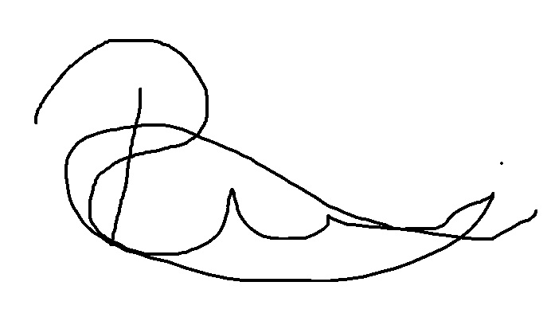
Approved by: | Date: | 18th February 2021
 | Name/Position: | Sarah Sheath, SOP Controller
 | Signature:
 | Date: | 19th February 2021

This Form will normally be reviewed every 3 years unless changes to the legislation require otherwise

Version History Log

This area should detail the version history for this document. It should detail the key elements of the changes to the versions.

Version | Date Implemented | Details of significant changes
1.0 | 20th December 2019 | This templated was created for use to replace a now obsolete form - Pharm/F97 as the process needed to be adaptable for different study requirements
2.0 | 15th March 2021 | Change of author. Minor changes only.

Adapt the form to suit the individual needs of a study that requires pharmacy monitoring when IMP is kept outside of pharmacy clinical trials.
[Insert study name]
Clinical trial
R&D Ref: [ ]

[Insert study name] monthly pharmacy monitoring form

Complete the table below while performing the monthly monitoring check, if you notice an issue while performing the monitoring check write them in the space provided and follow up on the issues while at the clinic or on your return to pharmacy.

 | Please tick |  | If the task was unable to be performed or issues have occurred please state them below and document the corrective measures
Is the temperature monitoring device working? | Yes  
Is the temperature monitoring device working? | No  
Is the temperature monitoring device within its calibration date? | Yes  
No
❑
Have you downloaded and reset the temperature monitoring device or replaced it with a new one? | Yes  
No
❑
Have there been any temperature excursions? | Yes  
Have there been any temperature excursions? | No  
Are all stocks within a suitable expiry date? | Yes  
Are all stocks within a suitable expiry date? | No  
Check the IMP Accountability Log and ensure it correlates to the physical stock level? | Yes  
No
❑
Is there enough stock of the IMP?  If not arrange for more to be ordered on your return to pharmacy | Yes  
No
❑
Have the research team or delegate been recording the daily temperature record? | Yes  
No
❑
Is there any patient returns/expired or damaged IMP that needs returning to pharmacy? | Yes  
No
❑

Clinic site/location of monthly check
Date monthly checked performed
Monthly checked performed by | Print | Sign | Date

Once complete store in section 17 of the pharmacy site file

