Spine Template

This Template should be used in conjunction with R&D/S35

IT IS THE RESPONSIBILITY OF ALL USERS OF THIS SOP TO ENSURE THAT THE CORRECT VERSION IS BEING USED

All staff should regularly check the R&D Unit’s website and/or Q-Pulse for information relating to the implementation of new or revised versions. Staff must ensure that they are adequately trained in the new procedure and must make sure that all copies of superseded versions are promptly withdrawn from use unless notified otherwise by the SOP Controller.

The definitive versions of all R&D Unit SOPs appear online. If you are reading this in printed form check that the version number and date below is the most recent one as shown on the R&D Unit website: www.research.yorkhospitals.nhs.uk/sops-and-guidance-/ and/or Q-Pulse

SOP Reference: | R&D/T09
Version Number: | 2.0
Author: | Laura Jeffery
Implementation date of current version: | 2nd October 2019

Approved by: | Name/Position: | Lydia Harris, Head of R&D
Approved by: | Signature: | 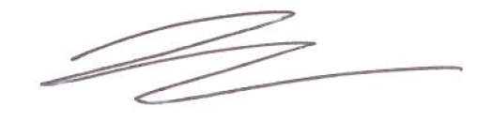
Approved by: | Date: | 4th September 2019
 | Name/Position: | Sarah Sheath, SOP Controller
 | Signature:
 | Date: | 4th September 2019

This SOP will normally be reviewed at least every 3 years unless changes to the legislation require otherwise

Version History Log

This area should detail the version history for this document. It should detail the key elements of the changes to the versions.

Version | Date Implemented | Details of significant changes
1.0 | 23rd October 2017
2.0 | 2nd October 2019 | Change of link to R&D website.

R&D Reference:

EudraCT Number:

Sponsor:

PI:

Research Team:

File _ of _

