Clinical Trials
Training package &
Competency workbook

This form is to be used in conjunction with SOP Pharm/S49

IT IS THE RESPONSIBILITY OF ALL USERS OF THIS FORM TO ENSURE THAT THE CORRECT VERSION IS BEING USED

All staff should regularly check the R&D Unit’s website and/or Q-Pulse for information relating to the implementation of new or revised versions. Staff must ensure that they are adequately trained in the new procedure and must make sure that all copies of superseded versions are promptly withdrawn from use unless notified otherwise by the SOP Controller.

The definitive versions of all R&D Unit SOPs appear online. If you are reading this in printed form check that the version number and date below is the most recent one as shown on the R&D Unit website: www.research.yorkhospitals.nhs.uk/sops-and-guidance-/ and/or Q-Pulse

Form Reference: | Pharm/F115
Version Number: | 3.0
Author: | Rachel Spooner
Implementation date of current version: | 26th October 2021

Approved by: | Name/Position: | Cheryl Donne, Principal Pharmacy Technician
Approved by: | Signature: | 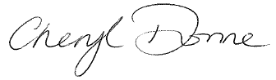
Approved by: | Date: | 25th October 2021
 | Name/Position: | Sarah Sheath, SOP Controller
 | Signature:
 | Date: | 26th October 2021

This Form will normally be reviewed every 3 years unless changes to the legislation require otherwise
Version History Log

This area should detail the version history for this document. It should detail the key elements of the changes to the versions.

Version | Date Implemented | Details of significant changes
1.0 | June 2016 | Version 1.0 was only published on pharmacy Q-pulse and not available on the R&D website
2.0 | 18th March 2019 | Separated from SOP on to a form format. Updated R&D website links reduced the amount of dispensing validation and removal of revalidation of items to fit with pharmacy departmental changes. Training of sending stock on transport to Scarborough site. Added section about signing delegation logs. Revision of tasks relevant to different job roles. Added videos as learning resources.
3.0 | 26th October 2021 | Changes to various delegated duties within training table at the front of workbook. Added section about reviewing and amending SOPs. Changes made to labelling section to reflect changes in clinical trials labelling procedure. Sub-sections added to amendment sections for Pharmacy technicians/SATOs and ATOs.

Clinical Trials

Training package
&
Competency workbook

Name ……………………………………………

Date issued:……………

Job Role: …………………………

Training Mentor:………………………..

Welcome to Pharmacy Clinical Trials,

This training pack has been developed to provide targeted training for all Pharmacy technical staff that have a role in the Pharmacy Clinical Trials Service. It provides different levels of training for different pharmacy job roles.

The table below outlines which levels of training are applicable to your job role. Please complete all sections that are relevant to you.
Section | Assistant technical officer | Senior assistant technical officer | Rotational technician | Senior pharmacy technician | Clinical trials manager
Section 1:  Introduction to clinical trials | ✓ | ✓ | ✓ | ✓ | ✓
Section 2:  Standard operating procedures | ✓ | ✓ | ✓ | ✓ | ✓
Section 3:  GCP and CV | ✓ | ✓ | ✓ | ✓ | ✓
Section 4:  Temperature monitoring,  stock take & CPD ward list | ✓ | ✓ | ✓ | ✓ | ✓
Section 5:  File maintenance | ✓ | ✓ | ✓ | ✓ | ✓
Section 6:  Access to labels | ✓ | ✓ | ✓ | ✓ | ✓
Section 7:  Dispensing |  | ✓ | ✓ | ✓ | ✓
Section 8:  Returns | ✓ | ✓ | ✓ | ✓ | ✓
Section 9:  Order, receipt, transfer of IMP and quarantine | ✓ | ✓ | ✓ | ✓ | ✓
Section 10:  Amendments | ✓  Role specific | ✓  Role specific | ✓  Role specific | ✓ | ✓
Section 11:  Site initiation visits & monitoring visits | ✓  Role specific | ✓ | ✓ | ✓ | ✓
Section 12:  Accuracy checking of clinical trial prescriptions |  |  |  | ✓ | ✓
Section 13:  Set up & closure of study | ✓  Closure only | ✓ | ✓  Role specific | ✓ | ✓

Section 1: Introduction to Clinical Trials

What are clinical trials?

Clinical trials are a set of procedures in medical research and drug development that are conducted to allow safety (or more specifically, information about adverse drug reactions and adverse effects of other treatments) and efficacy data to be collected for health interventions (e.g., drugs, diagnostics, devices, therapy protocols). Clinical trials are an essential part of advancing healthcare and developing new therapies. They provide the basis of evidence-based medicine as well as the information needed by the regulatory authorities to allow drugs to become licensed. Clinical trials can only take place after satisfactory information has been gathered on the quality of the non-clinical safety, and MHRA/Health Authority/Ethics Committee approval is granted.

Examples of what a clinical trial may be designed to do:

- Assess the safety and effectiveness of a new medication or device on a specific kind of patient (e.g., patients who have been diagnosed with a specific disease)
- Assess the safety and effectiveness of a different dose of a medication than is commonly used (e.g. 10mg dose instead of 5mg dose)
- Assess the safety and effectiveness of an already marketed medication or device for a new indication, i.e. a disease for which the drug is not specifically approved for use
- Assess whether a new alternative medication is more effective for the patient’s condition compared to the existing medication.
- Compare the effectiveness in patients with a specific disease with two or more approved treatments (e.g. Treatment A vs. Treatment B)

However, clinical trial support and the dispensing of trial drugs is an area of pharmacy practice which isn’t always well explained or understood by those required to do the dispensing or supplying of the drugs. It is often considered an extra task and not necessarily one that Pharmacists and pharmacy technicians feel confident in carrying out.

This booklet is intended to give you a greater understanding of the background of clinical trial conduct and to provide hints and tips to allow a smoother execution of clinical trial support by pharmacy. It is not intended to be a comprehensive guide to the regulations relating to clinical trials but rather a practical guide.

Good Clinical Practice (GCP)

The International Conference on Harmonisation of Technical Requirements for Registration of Pharmaceuticals for Human Use (ICH) Good Clinical Practice (GCP) is globally applicable guidance that sets the foundations for the conduct of all clinical research. All clinical trials conducted in the UK should follow GCP as this is a legal requirement under the UK Medicines for Human Use (Clinical Trials) regulations.
The cornerstones of GCP are the protection of the rights, safety and wellbeing of human subjects, and the provision of accurate and credible clinical trial data. In any clinical trial, the interests of an individual subject should always be considered more important than the interests of society.

GCP arose in response to various widely publicised drug disasters as well as unethical conduct in a number of clinical trials.

The Tuskegee study was an investigation into syphilis carried out from the 1930s until the 1970s. Although when the study initially started it gathered useful information on syphilis, the people in whom the study was conducted were poor and uneducated African American men in Tuskegee, Alabama who were given inducements to participate. This was the initial unethical side to the study: in addition to this, during the course of the study the effectiveness of penicillin in treating syphilis was discovered but this information was kept from the study participants, who were not offered penicillin treatment for many years. Lessons learned from this study were included in the section in the GCP regulations that state if any new information becomes available about their disease or the drug during the course of a study, then the study participants must be informed of this.

Perhaps the most infamous instances of unethical clinical research were the experiments carried out by the Nazi concentration camps on prisoners of war. This led to the Nuremberg code, which was formed to ensure that never again would anyone be forced to participate in a clinical trial. The main part of this is ‘informed consent’, which should be given by a study participant freely without coercion.

These principles were taken further by the World Medical Association in 1964 in the Declaration of Helsinki, which lays out the Ethical Principles for Medical Research involving Human Subjects. This document has been revised many times, most recently in October 2013.

Key Elements of GCP

Informed Consent
Everyone who participates in a clinical trial should give written, informed consent prior to any study specific procedure being carried out; this should be documented on a signed consent form. To be ‘informed’, a patient should be given written information and be able to ask the doctor in charge of the clinical trial – the Principal Investigator (PI) - questions. GCP contains a list of essential elements that must appear in the informed consent documents, such as information about the clinical trial, patient rights, foreseen risks, and what restrictions are in placed on that patient.

Qualifications
Everybody who does any work in a clinical trial must be suitably qualified and trained to undertake that task. This suitability is usually documented in the person’s curriculum vitae (CV) and training record. Any general training can be added to a CV. Most Clinical trials now specify the requirement for all staff that are involved in the trial to be GCP trained and have a current GCP certificate (GCP training is valid for 2 years then a refresher course will need to be attended).

Documentation
As with many walks of life, and much of normal pharmacy practice, the ethos of clinical trials is “if it isn’t documented, then it didn’t happen”. Anything related to a clinical trial should be written down. The first place that anything is noted down is called source data. If this is on the back of a piece of scrap paper that the pharmacist had in their pocket when the study team gave them information then that piece of

paper must be filed. That information can be transcribed onto any pieces of paper necessary but the first place it is written is the only source.
On no account should any source data be destroyed. This would be an extremely serious breach of GCP. A common reason for destroying source data is that the information has been written up neatly to make it easier to read. It is acceptable to clarify information in this way, but the original data must be kept as well.
There are rules on how corrections are made, which is similar to the way that changes are made in controlled drug registers i.e. any changes to data should be made by crossing out the original data with a single line so that it is still legible, writing the new data next to the old data, and verifying the changes by initialling and dating them.

Ethical and Regulatory Approval
Before a clinical trial can take place it must have received approval from an ethical committee and also the country’s regulatory authority, if applicable. The pharmacy department running the clinical trial would not normally be involved in getting these approvals, but a copy of the relevant approval letters should be obtained and filed in the pharmacy site file. The UK competent authority for authorising clinical trials is the Medicines and Healthcare Regulatory Agency (MHRA). Conduct of clinical trials must follow the UK Medicines for Human Use (Clinical Trials) Regulations 2004.
Multinational studies will need to comply with the relevant regulations for each country. In the USA, for example, this is the Food and Drug Administration (FDA) regulations. In March 2016 changes were made regarding ethical and local NHS approvals, the new HRA (Health Research Authority) approval has replaced these. All new studies obtaining approval from this date will have HRA approval, this process is expected to reduce the amount of time required to set-up studies at individual sites.

Confidentiality
Any volunteers participating in a clinical trial should have their personal data protected and stored confidentially. To ensure this, each volunteer is assigned one or more unique identifying numbers. Depending on the study, these may be referred to the screening number, screening ID, enrolment number, randomisation number, patient number, randomisation code or other similar words.
The only time a patient name should be used in correspondence is within the study centre; that is, between the study nurse, the patient’s consultant and the pharmacy. In correspondence with any external bodies e.g. the sponsor, the patient should be referred to by their unique number, which should also be written on the study specific prescription received by pharmacy.

Inspections/ Audits
To ensure the quality of the data as well as the safety of the volunteers, a study site may be audited or inspected. Inspection/audits, as well as routine study monitoring, could be carried out by the study sponsor, ethics committee or regulatory authorities, both from the UK (MHRA) and other countries. Reasons for an audit can be varied and there are different triggers for inspections/audits. If a study site is suspected of a breach of the regulations or fraud, the site would usually be audited as part of a full investigation. Even if the pharmacy wasn’t suspected of being involved in the possible fraud, the pharmacy is still likely to be audited. This could be during the study or when the study is closed.
An audit may also be carried out if there were recurrent episodes of bad practice at the site. In addition, certain types of studies are more liable to be audited, e.g. a study in which data has been collected that is pivotal to the registration of a product. Alternatively, an audit could occur simply because companies have a certain number of randomly chosen audits to carry out in a year.

The pharmacy would usually be visited in the course of an audit simply because of the importance of drug dispensing in the study conduct. The MHRA can carry out Good Manufacturing Practice (GMP) audits as well as GCP audits.

Clinical Trial Design

Blinding
Blinding means that the participant, the investigator, or both, are unaware of which drug the patient is taking. A clinical trial is single blinded if either the patient or the investigator (but not both) is unaware of what they are taking; it is double blinded when neither the patient nor the investigator are aware of the patient’s allocated treatment. When a clinical trial is double blinded, it is usual for the sponsor to be blinded also.
The purpose of blinding is to reduce observation bias. If a patient doesn’t know what they are taking, it can’t influence their reporting of symptoms. Likewise, if the investigator doesn’t know what the patient is taking, it can’t influence their assessment of the patient. This means that any apparent effectiveness of treatment can be attributed to the treatment rather than expectations that a treatment will be effective.
The pharmacy department may or may not be blinded and are often the only people who know what treatment a patient is taking. In some clinical trials, drugs are provided by the sponsor in pre-randomised packs, meaning the pharmacy is unaware of which drug is allocated to which randomised code. However, in some clinical trials, the pharmacy will be provided with unblinded drugs; when a patient is entered in a clinical trial, the pharmacist will refer to a randomisation list which specifies which treatment to dispense.
When pharmacy is not blinded; it is absolutely imperative that pharmacists and technicians ensure that they do not unblind anyone associated with the clinical trial. Unblinding may involve revealing which treatment a patient is taking, or it could mean letting it be known that, for example, patients 11 and 13 are taking the same drug and that is different to that taken by patient 14. The need for care to ensure blinding is maintained may appear obvious, and unblinding is likely to be done intentionally, but there are many cases where pharmacy can accidently unblind a study. For example, dispensing documents should not be made available to the study monitor, if the monitor is blinded.

Randomisation
Most clinical trials are randomised. This means each patient enrolled into the clinical trial has a random chance of being assigned to any treatment group.
Randomisation is done for 2 reasons. Firstly, it means patients are not assigned to a given group- either consciously or subconsciously- for a particular reason, such as their health status. This eliminates selection bias. Secondly, each individual will have a number of characteristics that will influence the outcomes of a treatment. Randomly assigning patients to a clinical trial arm means that (providing the clinical trial is sufficiently large) these characteristics are evenly spread between the groups and therefore will not impact on the results. This eliminates confounding.
Many studies use a phone system (Interactive Voice Response System –IVRS) or a web based system (Interactive Web Response System – IWRS) to randomise patients. These systems allow a much better control of randomisation as they consider all patients enrolled in the clinical trial, across all sites, rather than just those randomised at an individual site.
The actual process of randomisation is described in the clinical trial protocol. The usual method is that when a patient is ready to be randomised, the next unused

sequential number is assigned to that patient. This can be done via a list of predefined numbers assigned to a particular centre, or an IVRS/IWRS can be used whereby the next available number across all sites is assigned.

Once a randomisation number has been assigned to a patient, the actual treatment associated with this randomisation number can be dispensed via 2 main methods. The first is where packs of pre-packed drugs are provided with the randomisation number on them already and are selected as appropriate. Secondly, the correct packs of drugs provided in bulk, e.g. a pot of active tablets and a pot of placebo tablets, a randomisation list stating which treatment a particular number corresponds to is provided to the pharmacy, and then the drugs are dispensed in accordance with the randomisation list, e.g. it may indicate that patient number 35 is to be assigned to active treatment and number 36 to placebo. The correct treatment is then dispensed according to this list and documented in the pharmacy file.

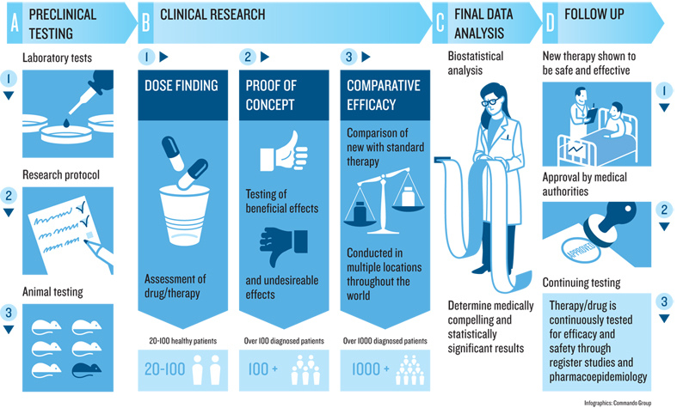
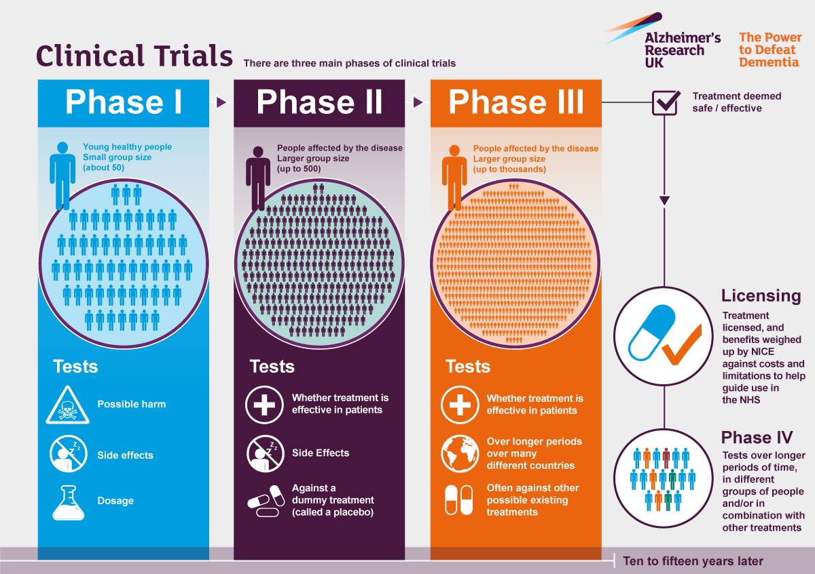
Phases of Clinical Research

Documents used in Clinical Trials

Protocol
The protocol is a document that describes the objectives, design, methodology, statistical considerations and organisation of a clinical trial. It must receive ethical and regulatory approval prior to implementation, and this is usually done before pharmacy is involved. Once the protocol is approved, any substantial changes planned in the conduct of the clinical trial must be documented in a protocol amendment, which must also be approved prior to these changes being implemented. Some sections of the protocol are of particular importance to the pharmacy, these relate to the drug preparation, dispensing, randomisation, risks and side effects of the drug and pharmacy documentation.

Pharmacy Documents
The protocol may refer to other documents used in the conduct of a clinical trial. In some clinical trials the format of these documents is contained in the protocol. If this is the case, the pharmacy documents must be used as approved. If any additional information is required by your local regulations then this should be recorded as supplementary documents.
If the pharmacy documents are not part of the protocol and are not submitted to Ethics for review, then it should be possible to make amendments to these documents to fit with local practice. This should then be discussed before the clinical trial starts. It is necessary to see the drugs and the labelling/packaging prior to any documents being finalised. This allows for any additional labelling requirements to be added to the process if necessary. All dispensed drugs need to have ‘For Clinical Trial Use Only’ printed on the label. Specific prescriptions for a clinical trial will also be necessary. Pharmacy is responsible for documenting all drug movements within a trial.

Investigator Brochure
This contains information on the drug being used in the trial, ranging from the chemistry and structure of the drug to the clinical experience to date. The document is required to be updated regularly, at least once a year, and the updates should be received by pharmacy. It is a useful document for pharmacy as it contains information on the physical, chemical and pharmaceutical properties of the drug.

Qualified Person Release Certificate and Certificate of Analysis
The sponsors cannot supply any medicinal products for use in a clinical trial without employing the services of a Qualified Person (QP) to verify that the batch is in compliance with the GMP regulations and the Clinical Trial Authorisation granted by the competent authority/ regulatory body in the UK (MHRA). A certificate of analysis reports the results of tests carried out to determine the quantity of active ingredients in a product, along with the chemical composition, the purity, storage conditions and the expiry date. A QP release certificate is a certificate containing a statement from the QP responsible for the drug’s release for use.
The QP Certificate of Release must state that the batch release has been manufactured in accordance with GMP regulations and the Clinical Trial Authorisation granted by the competent authority or regulatory body (MHRA). Pharmacy may request this information to verify the compliance of the drug with the Clinical Trial Authorisation, and these records are usually held with the sponsor and must be available for inspection. Drugs must be manufactured under GMP conditions at a GMP licensed unit.

Practical aspects of working on a clinical trial

When the pharmacy department is asked to be involved in a clinical trial, it is important that the protocol is reviewed at an early stage to identify any potential problems with the organisation of the clinical trial at the site or with the drug. The pharmacy should consider the logistics of participating early on.

Key things to consider
When considering the practicalities of dispensing clinical trial drugs, some consideration for the set-up of the trial are:
- At what stage is the patient randomised?
- At what times must the drugs be dispensed?
- What is the turnaround time needed from notification to pharmacy until the drug is required?
- Are rescue drugs provided to the patient and how do they access them?
- What are the storage requirements?
- How much space will be required?
- How are the supplies of drugs obtained?
- Are there any drugs that the patient should not be taking whilst participating in the trial?
- Is the trial likely to need the on-call pharmacist service?
- Will pharmacy be holding the unblinding information for the trial?
- How much time is needed for dispensing?
- Is there a comparator or additional medication? If so, are pharmacy to source and supply?
- Are the drugs to be collected by the patient or research staff?
- What is the estimated recruitment target?

Staff dispensing a clinical trial drug must ensure that they follow the protocol or pharmacy dispensing procedure and complete all accountability and inventory logs for the drug. In addition, study labels must be legible and information must be completed for each pack supplied. The study specific prescription and logs must be filed after checking in the pharmacy site file, in order to maintain the audit trail.

Patient counselling
Patients involved in clinical trials are likely to be very well informed about their drug as the study investigator should have covered this in detail. However, as when dispensing any drugs, the person handing out the drugs should ensure that the patient knows exactly how to take the drug. Any concerns or questions should be dealt with as usual, but with careful reference to information in the protocol or the ethics-approved Patient Information Leaflet (PIL). Often it is the research nurse or investigator who collects the drugs and provides information to the patient. This should be discussed during the set-up.

Patient Eligibility Criteria
The protocol will list the criteria that a patient must meet to be eligible to participate in the clinical trial. This is in the form of inclusion/ exclusion criteria.
When dispensing clinical trials, the pharmacy would not expect to check whether the patient meets criteria eligibility, or whether they have given informed consent. However, if a discrepancy is spotted then this should be reported to the study team.

In nearly every clinical trial there are exclusion criteria relating to medication that should not be taken by the patient whilst participating in the trial. There are two main reasons for this. Firstly, taking a particular medication may impact on the meeting of study objectives. It may be medication that patients should not have taken; for example, if the study is focused on steroid-naïve asthmatics, steroids should not be taken. Or, it may be a drug that should not be taken in the run-in period or the study itself (drugs with the same clinical effect as the trial drug).
Secondly, there may be a pharmacokinetic or pharmacodynamic interaction with the trial drug. The interaction could affect:-
- Patient safety- either by altering the amount of drug absorbed, or by causing an antagonist or synergistic pharmacodynamics effect.
- Study outcome- if the patient is taking an interactive drug it will affect the study analysis.

Study Initiation Meeting
This should take place prior to the start of the study and the pharmacy department must be involved to discuss dispensing. It is usually expected that a senior clinical trials pharmacist/ technician will attend the meeting. If possible, questions from the pharmacy department should be raised with the study sponsor prior to study initiation so as to allow an answer to be provided at the initiation meeting. If this is not possible, then all study documentation should be reviewed prior to the initiation meeting to allow any questions to be raised at the meeting.
Drugs should not be sent to the study site until all required approvals (ethics, regulatory approval and local NHS trust approval or HRA approval and regulatory approval) are in place. This means that the trial drugs may or may not be at the pharmacy when the initiation meeting happens.

Study Monitor
Monitoring is the responsibility of the sponsor. It involves overseeing the progress of a clinical trial and ensuring that it is still being conducted, recorded and reported in accordance with the protocol, any relevant SOPs, GCP and any regulatory requirements. The study monitor, sometimes called the Clinical Research Associate (CRA) or Clinical Research Scientist (CRS), will visit study sites during the study for three main types of visits:-
- Study Initiation Meeting
- Monitoring Visits- these occur during the study. The monitor may or may not visit pharmacy at every visit but they should notify pharmacy of the visit in advance.
The types of things that will be assessed during a visit to pharmacy are:
- Access to drugs- access should be restricted and supplies clearly marked ‘for clinical trial use only’.
- Storage of drugs- there should be documentation in place to record the temperature at which the drugs are stored in pharmacy (including ambient temperatures).
- Blinding- only unblinded staff should have access to any documents (to avoid accidentally unblinding blinded staff).
- To review documentation- drug accountability logs and dispensing records should be checked.
- Code Breaks- These should be checked to ensure they are intact.

- Close out visit- this is the final visit of the trial. The monitor will usually be unblinded (pharmacy should check this prior to visit) and do a full drug accountability. The fate of any remaining drug supplies will be discussed: they

may be returned to the sponsor, or destroyed locally. If they are to be destroyed locally then a certificate of destruction should be provided. Retention of documents and any other requirements will also be discussed.

Investigational Medicinal Products (IMPs)

Storage
During clinical trials, the IMP may yet have to undergo the full stability testing required for a licensed product. For example, many trial drugs have short expiry periods, not because they degrade rapidly, but because their long-term stability has not yet been tested, long-term testing is done in parallel to the clinical trial, trial drugs that have already been supplied to pharmacy may have their expiry extended on an ongoing basis throughout the trial (MHRA approval is needed).
A temperature range within which drugs are to be stored may be specified. If the temperature is outside of this range, the sponsor should be immediately notified (a temperature excursion has occurred) as the drugs still may be used. For example, there may be stability data to confirm that in a situation in which a drug is left out of the fridge for less than 7 days, the drug could still be used, but the expiry should be one month after removal from the fridge. It is critical that all actions taken are documented and that a file note is placed in the pharmacy file. The drug must be quarantined until the sponsor of the trial has given permission to alter the expiry date and confirmed in writing.

Drug Availability
You should remember that during a clinical development, the amount of drug substance available is very limited and this often impacts on the decisions made relating to the study conduct. For example, rather than getting delivery at the start of the trial for enough drugs for the 20 patients your site is expected to recruit, you may only receive enough for 2 patients initially to prevent waste if recruitment is poor.
Initial discussions with the sponsor should include queries regarding drug supply to ensure adequate stock for the duration of the trial. In addition, agreements on continuation of drug supply after the patients have finish the trial may be made in certain circumstances where the drug has been a successful treatment for the intended group of patients with a particular disease. The sponsors may agree to a compassionate-use basis until the drug has been granted a marketing authorisation. Often this is a condition that needs to be approved by the ethics committee.

Documentation
All documents in the pharmacy that must be kept during the study may be provided but, if not, they need to be prepared locally. Information required to be kept usually includes a tally of the drugs received, a running balance, and a record of each individual dispensing. It may be possible to do this on a single document, but usually multiple documents are required. The following information is the type of information that you are required to note on the accountability log:-
- Batch number of drug
- Patient ID
- Randomisation number
- Proof that any protocol requirements are met during dispensing
- Date of which drugs are received/dispensed/returned/destroyed

Fraud
Fraud can sometimes occur in clinical trials and can take many forms. Data may be fabricated or altered for financial, prestige, or other motivations. Whatever the reason,

if fraud is suspected it must be investigated. The usual action by pharmacy would be to discuss their concerns with the study monitor and, in more serious circumstances, to contact the regulatory body (MHRA).

What are the requirements for labelling?
There are specific labels for each trial; these labels have been created to contain all of the legal requirements. Clinical trial labels must contain the following information (as listed in the EU guide to Good Clinical Practice Annex 13):
- Name. address and telephone number of the sponsor, contract research organisation or investigator (the main contact for information on the product, clinical trial and emergency unblinding)
- Pharmaceutical dosage form, route of administration, quantity of dose units, and in the case of open trials, the name/identifier and strength/potency
- The batch and/or code number to identify the contents and packaging operation
- A trial reference code allowing identification of the trial, site, investigator and sponsor if not given elsewhere
- The trial subject identification number/ treatment number and where relevant, the visit number
- The name of the investigator (if not included in (a) or (d))
- Directions for use (reference may be made to a leaflet or other explanatory document intended for the trial subject or person administering the product)
- “For clinical trial use only” or similar wording
- The storage conditions
- Period of use (use-by date, expiry date or re-test date as applicable), in month/year format and in a manner that avoids any ambiguity.
- “Keep out of the reach and sight of children” except when the product is for use in trials where the product is not taken home by subjects

What needs to be done at the time of dispensing?
This varies depending on the individual protocols, there are dispensing guides at the front of each study file. All documentation will need to be completed by the technician and pharmacist.
Details of the quantity dispensed, batch numbers and expiry dates will need to be recorded on the drug accountability logs.
Any dispensing for a clinical trial will need to be checked by a pharmacist/accuracy checking technician.

Who can collect dispensed clinical trials?
The dispensed prescription can be collected by the patient or a member of staff involved in the trial (research staff, chemo nurses, investigators/ co-investigators). However, in clinical trials where some staff are blinded it is important to maintain the blind and allow designated staff to collect the prescription. Dispensed clinical trials can only be collected if they are going to be used immediately or are being delivered to the patient at that time. This is to avoid clinical trial medication being stored for a length of time in an area that isn’t temperature monitored.
Clinical trial medication dispensed at one site should not be administered at another site (e.g. Bridlington, Malton or Whitby hospital) unless the site has been approved by the Sponsor and is indicted on the trial contract.

What is a file note?
A file note is completed for any discrepancy that occurs, this could just be to explain the correct location of paperwork, where any temperature logs are stored, or any documentation errors.

The file note will need to be completed by a member of staff that is GCP validated, and signed by either the Lead Pharmacist or the senior clinical trial technician. Depending upon the trial we may have to send an electronic version to the Clinical Trial Monitor and their details will be found in the Pharmacy File.

Clinical trials terminology

ARM
A group or subgroup of participants in a clinical trial that receives specific interventions, or no intervention, according to the study protocol. This is decided before the trial begins.

BASELINE
Baseline information is gathered at the beginning of a study from which variations found in the study are measured. Baseline can also be described as a known value or quantity with which an unknown is compared when measured or assessed. Safety and efficacy of a drug are often determined by monitoring changes from the baseline values.

CROSSOVER TRIAL
A clinical trial in which all participants receive both treatments, but at different times. At a predetermined point in the study, one group is switched from the experimental treatment to the control treatment (standard treatment), and the other group is switched from the control to the experimental treatment.

DOUBLE BLIND MASKING
A type of Masking in which two or more parties involved in the clinical trial do not know which participants have been assigned which interventions. Typically, the parties include the investigator and participants.

DOUBLE – DUMMY
A technique for retaining the blinding of a clinical trial, where the two treatments cannot be made identical.
In the example shown below the patient will always receive an injection drawn up from a vial and will always receive pre-filled syringe injection regardless if they are in treatment group A or B. In treatment group A the vial contains the active drug and the pre-filled syringe contains placebo. In treatment group B, the pre-filled syringe contains the active drug and the vial contains placebo.
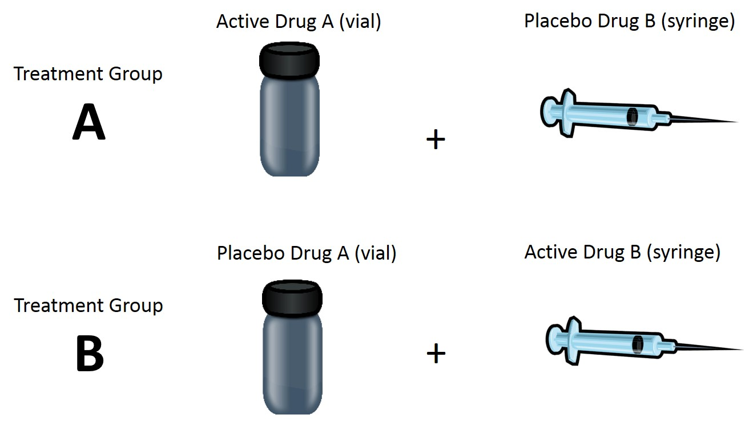

EFFICACY
(Of a drug or treatment) the ability of a drug or treatment to produce a beneficial result. A drug demonstrates efficacy if it is effective at the dose tested against the illness for which it is prescribed.

INTENT TO TREAT
Analysis of clinical trial results that includes all data from participants in the groups to which they were randomized even if they never received the treatment.

INTERVENTION
A process or action that is the focus of a clinical study. Interventions include drugs, medical devices, procedures, vaccines, and other products that are either investigational or already available. Interventions can also include non-invasive approaches, such as surveys, education, and interviews.

MASKING OR BLINDING
A clinical trial design strategy in which one or more parties involved in the trial, such as the investigator or participants, do not know which participants have been assigned which interventions. Types of Masking include Label, Single, and Double Blind Masking.

OPEN LABEL
Describes a clinical trial in which masking is not used. This means that all parties involved in the trial know which participants have been assigned which interventions.

PARALLEL STUDY
A parallel designed clinical trial compares the results of a treatment on two separate groups of patients. The sample size calculated for a parallel design can be used for any study where two groups are being compared.

PLACEBO
A substance that does not contain active ingredients and is made to be physically indistinguishable (that is, it looks and tastes identical) from the actual drug being studied.

PLACEBO EFFECT
A physical or emotional change, occurring after an inactive substance is taken or administered, that is not the result of any special property of the substance. The change may be beneficial, reflecting the expectations of the participant and, often, the expectations of the person giving the substance.

RANDOMIZED ALLOCATION
A method based on chance by which study participants are assigned to different treatment groups. This minimizes the differences among groups by equally distributing people with particular characteristics among all the trial arms, thereby avoiding “selection bias.” Randomization allows for researchers to comparably test different treatments in similar groups.

SINGLE-BLIND STUDY
A study in which subject or patient is unaware of what medication they are taking, while the physician does know.

Now you have read the underpinning knowledge please answer the reflective questions below. Discuss your answers with your mentor.

- What do you think the pharmacy team should consider before agreeing to supply drugs as part of a clinical trial? What barriers may prevent a pharmacy from participating in clinical trials?

- What do you think are the main concerns patients have when they are considering participating in a clinical trial?

- What is your understanding of Good Clinical Practice? What are some of the key ways it guides clinical trials?

- In what situation would you reveal to a patient participating in a clinical trial whether they were taking a placebo or active treatment?

- What are the essential documents for a clinical trial that are kept in the pharmacy?

Case study: The PROUD study

In the pharmacy clinical trials team we often get asked about the results of the studies we facilitate and what impact they have on the participants that take part in them.

One study that we facilitated as a Trust was the PROUD study. The videos linked below will help you understand how the PROUD study was conducted and how its results have had an impact on people’s lives.
https://vimeo.com/128625001

https://vimeo.com/214791866 (contains some strong language and sexual references)

Importance of good clinical practice in drug trials

Watch the video of a stage one study found at: https://www.youtube.com/watch?v=a9_sX93RHOk

Thank about all the points where you could see how the study could be improved to prevent the dangers from happening.

Section 2: Standard operating procedures (SOPs)

All the most up-to-date clinical trials SOPs are located on the Research and Development website. https://www.research.yorkhospitals.nhs.uk/
When you are on the website you will be able to locate the pharmacy SOPs, forms and templates under the SOP and guidance heading on the right hand side of the home page. Once you have read these SOPs you must then log on to QPulse to acknowledge that you have read and understood them.

Once you have read all the SOPs relevant to your job role ask you mentor to review QPulse and sign and date below to approve that you have read the applicable SOPs.

I ………………………………confirm that …………………………………………

has read and acknowledged all the relevant SOPs, forms and templates applicable to

their job role as a……………………………….

Signed:………………………………………….Date:……………………………..

Reviewing and Amending SOPs
All Pharmacy Clinical Trials SOPs are required to be reviewed and amended if necessary every 3 years. In addition, study-specific SOPs (located in Section 1 of the Pharmacy Site Files) are often reviewed and amended as part of amendments or changes in legislation or Trust practices.

Your mentor will explain to you the process of requesting Pharmacy SOPs from the Research and Development team, reviewing and amending these SOPs. They may also explain how and why we may amend study-specific SOPs.

You will then be allocated an SOP to review and amend. The type of SOP you are given to review and amend will be appropriate to your job role. Get your work checked by your mentor.

 |  | Date |  | Signed by trainee |  | Signed by trainee
Demonstration by mentor
Reviewing and amending SOPs
Name of SOP | Date started |  | Signed by trainee |  | Signed by mentor |  | Date completed

Section 3: Good clinical practice (GCP) and Curriculum vitae (CV)

To work on any clinical trial you must complete GCP training and create a CV.

GCP

Online GCP training can be completed on the National institute of health research website www.learn.nihr.ac.uk. Once completed you must save your certificate on the x:drive. GCP training must be revisited every 2 years and it your responsibility to do so.

CV

Create a CV using the template on the Research and Development website. A signed copy must be saved to the x:drive. Your CV must be up dated every year and it is your responsibility to maintain this.

Signing on to delegation logs

Once you have created a CV and completed GCP training you will need to sign on to the study delegations logs. Only sign for responsibilities relevant to the roles and responsibilities you will be performing. Your mentor will help you organise meeting with the research teams to sign on to the delegation logs.

Section 4: Temperature monitoring, stock take and CPD ward list.

Temperature monitoring

Monitoring the environmental temperature of where Investigational medical products (IMP) are stored is a very important part of clinical trials. Sponsors give guidelines of how they want us to store the IMP as it can alter the results of a trial as well as causing harm to the patient if the product has altered stability.
All areas that store IMP have a temperature monitor which gets read and recorded daily.
Daily temperature reading and recording
 | Date | Signed by trainee | Signed by mentor
Demonstration by mentor
Observation 1
Observation 2
Complete the observations below:

Weekly reset of temperature loggers
 | Date | Signed by trainee | Signed by mentor
Demonstration by mentor
Observation 1
Observation 2

Stock take

A clinical trials stock take occurs once a month. All stock kept within pharmacy clinical trials must be accounted for during this check. This is essential to ensure we do not have out of date products that could be used.

Complete the observations below:

Monthly stock check of clinical trials stock
 | Date | Signed by trainee | Signed by mentor
Demonstration by mentor
Observation

CPD ward list

Every morning the pharmacy clinical trials team use the CPD system to see if any patients have been admitted as inpatients and are staying on a ward. As outlined in the SOP the relevant research teams and ward pharmacist should be informed of any inpatient on a clinical trial.

Daily check on CPD for clinical trial patients
 | Date | Signed by trainee | Signed by mentor
Demonstration by mentor
Observation 1
Observation 2
Complete the observations below:

Section 5: File maintenance

Name of trial | Date started | Signed by trainee | Signed by mentor | Date completed
All of the clinical trial files must be maintained on a regular basis to ensure all the documents are completed correctly and are stored accurately. Referring to the SOP maintain a clinical trial file which will be allocated by your mentor. Once complete ask your mentor to check and approve your work

Section 6: Access to Labels

The labels for Clinical Trials are stored on the X:Drive in the study-specific folders, and each label that is printed needs to be accounted for. Your mentor will show you where to locate the master label for a chosen study. Work with your mentor to ensure you can print the study-specific labels and are set up on the label printers within Clinical Trials.

I ………………………………confirm that …………………………………………

Has access to the trial labels on the X:Drive and can print copies of the labels.

Signed:………………………………………….Date:……………………………..

JAC labels – JAC labels are also required when dispensing/issuing some stock used in Clinical Trials. Work with your mentor to check that your printer settings are correct for JAC and that you can print labels in the correct format.

I ………………………………confirm that …………………………………………

has access to JAC and can print JAC labels in the correct format.

Signed:………………………………………….Date:……………………………..

Section 7: Dispensing

Prescription Type (Rx)
CTP | Clinical Trial Prescriptions
CCP | ChemoCare Prescriptions
Each clinical trial differs with their dispensing procedure. Each process is outlined in the individual sets of trial instructions.

When completing your log check a variety of clinical trial prescriptions.

If you make a major error or more than one minor error then your log must be brought to the clinical trials manager for review.

Error Codes ( * minor errors)
1. Incorrect drug/kit no./ bottle no. | 11. Incorrect quantity
2. Incorrect strength/dose | 12. Incorrect cost centre *
3. Incorrect form | 13. Missing item(s) from Rx
4. Incorrect patient name and/or trial number | 14. Missing signature *
5. Incorrect directions | 15. Missing supplementary items *
6. Correct drug/kit no./bottle no., incorrect label | 16. Incorrect calculation
7. Incorrect drug/kit no./bottle no., correct label | 17. Missing accountability log/s or incorrect completion
8. Patient allergy status missing  (NB. Rx should not be dispensed without an allergy status) | 18. Incomplete or incorrect completion of ‘For Pharmacy use’ section
9. Missing additional warning/s | 19. Prescriber not on the delegation log (NB. Rx must not be dispensed if the prescriber is not on the delegation log)
10. Expiry – missing, incorrect or expired stock | 20. Other

Dispensing Log
Dispensing Log
Item Number | Date | Name of trial | Prescription type | Final check | Error code
1
2
3
4
5
6
7
8
9
10

Dispensing Log
Item Number | Date | Name of trial | Prescription type | Final check | Error code
11
12
13
14
15
16
17
18
19
20

I ………………………………confirm that …………………………………………

has completed their log validation/revalidation (circle appropriate) of 20 items of

pharmacy clinical trial prescriptions.

Signed:………………………………………….Date:……………………………..

Section 8: Returns

Pharmacy clinical trial stock returns are processed on a regular basis. After reading the SOP observe your mentor conducting the returns process for a trial and then complete the log below.
Each item is classed as one item returned. There may be multiple items to be returned for one study.
 |  |  | Date |  | Signed by trainee |  | Signed by mentor
Demonstration by mentor
Pharmacy clinical trial stock returns log
Item Number | Date | Name of trial |  | Checked by mentor |  | Details of any errors detected
1
2
3
4
5
6
7
8
9
10

I ………………………………confirm that …………………………………………

has completed their log of 10 items of pharmacy clinical trial stock returns accurately.

Signed:………………………………………….Date:……………………………..

Section 9: Order, receipt, transfer of IMP and quarantine

Order IMP for a study
 |  | Date |  | Signed by trainee |  | Signed by mentor
Demonstration by mentor
Ordering IMP
Name of product needing to be ordered | Date order created |  | Signed by trainee |  | Signed by mentor |  | Date completed
Your mentor will work through an order for IMP with you. You can then process 2 orders for an IMP following the ordering procedure. Get your work signed and checked by your mentor.
Receipt of an order
Pharmacy stores will notify the clinical trials team of a delivery of IMP. Your mentor will work through a delivery of IMP with you. You can then process 2 deliveries of IMP following the relevant SOPs. Get your work signed and checked by your mentor.
 |  | Date |  | Signed by trainee |  | Signed by mentor
Demonstration by mentor
Receipt of IMP
Name of product received | Date delivery received |  | Signed by trainee |  | Signed by mentor |  | Date completed

Quarantine
There are numerous reasons why IMP may need to be quarantined so that it isn’t used because it might not be fit for purpose. Your mentor will work through putting IMP into quarantine with you. You can then add IMP which is not suitable for use in to quarantine following the relevant SOPs. Get your work signed and checked by your mentor
 |  | Date |  | Signed by trainee |  | Signed by mentor
Demonstration by mentor
Quarantine of IMP
Name of product received | Date delivery received |  | Signed by trainee |  | Signed by mentor |  | Date completed

Transfer of IMP across hospital sites or units
Studies that are run at the Scarborough site are dispensed at York and sent on hospital transport to the Scarborough site.
Your mentor will work through the transfer process with you. You can process the transfer of IMP following relevant SOP. Get your work signed and check by your mentor.
 |  | Date |  | Signed by trainee |  | Signed by mentor
Demonstration by mentor
Transferring of IMP across hospital sites or units
Name of IMP | Date product transferred |  | Signed by trainee |  | Signed by mentor |  | Date product reached the end site

Section 10: Amendments

SATO’s and Technicians:
Amendments to protocols or sponsor supplied documents arise on an ad-hock basis. Your mentor will work through an amendment with you relevant to your current job role. They will then allocate you an appropriate amendment for you to process using the SOP and relevant forms and templates. Depending on your role within the pharmacy clinical trials team will depend on the amendments you will be processing.
Get your work signed and checked by your mentor.
 |  | Date |  | Signed by trainee |  | Signed by trainee
Demonstration by mentor
Processing amendments
Name of trial amendment | Date started |  | Signed by trainee |  | Signed by mentor |  | Date completed

ATO’s:
Ensuring that all amendment paperwork is complete and filed correctly in the Pharmacy Site File and on the X:Drive is essential.
Your mentor will show you this process and will then allocate you an amendment to file. Get your work signed and checked by your mentor.

I ………………………………confirm that …………………………………………

Can file completed amendments accurately and knows how to check that the amendment paperwork is complete.

Signed:………………………………………….Date:……………………………..

Section 11: Site initiation visits (SIV) and monitoring visits

Site initiation visits (SIV)

Work with your mentor or another trained member of the pharmacy clinical trials team to prepare and attend a SIV.

Document below the details from the SIV meeting you attend:

Name of the prospective trial:

Date you attended SIV: Where was the SIV held:

How did you prepare for the SIV? (SATOs and Technicians only)

Details of any pharmacy related issues:

General overview of the outcome of the visit:

I ………………………………confirm that …………………………………………

attended a SIV for the …………………………….clinical trial on ............................

Signed:………………………………………….Date:……………………………..

Monitoring visits

Find out from a member of the clinical trials team when a monitoring visit for an open and recruiting trial is coming up. Prepare and facilitate for the monitoring visit and complete the information below:

Name of the trial:

Date of monitoring visit:

Name of CRA or monitor for the trial:

What did you do to prepare?

What were the outcomes of the monitoring visit?

I ………………………………confirm that …………………………………………

facilitated a monitoring visit for the …………………….clinical trial

on ............................

Signed:………………………………………….Date:……………………………..

Section 12: Accuracy checking of clinical trial prescription

If you are qualified and trained accuracy checking technician within the Trust you can validate in accuracy checking of a clinical trials prescriptions. Once you have completed the clinical trials dispensing log.

When completing your log check a variety of clinical trial prescriptions.

If you make a major error or more than one minor error then your log must be brought to the clinical trials manager for review.
Prescription Type (Rx)
CTP | Clinical Trial Prescriptions
CCP | ChemoCare Prescriptions

Accuracy checking Log
Error Codes ( * minor errors)
1. Incorrect drug/kit no./ bottle no. | 11. Incorrect quantity
2. Incorrect strength/dose | 12. Incorrect cost centre *
3. Incorrect form | 13. Missing item(s) from Rx
4. Incorrect patient name and/or trial number | 14. Missing signature *
5. Incorrect directions | 15. Missing supplementary items *
6. Correct drug/kit no./bottle no., incorrect label | 16. Incorrect calculation
7. Incorrect drug/kit no./bottle no., correct label | 17. Missing accountability log/s or incorrect completion
8. Patient allergy status missing  (NB. Rx should not be dispensed without an allergy status) | 18. Incomplete or incorrect completion of ‘For Pharmacy use’ section
9. Missing additional warning/s | 19. Prescriber not on the delegation log (NB. Rx must not be dispensed if the prescriber is not on the delegation log)
10. Expiry – missing, incorrect or expired stock | 20. Other

Accuracy checking Log
Item Number | Date | Name of trial | Prescription type | Final check | Error code
1
2
3
4
5
6
7
8
9
10

Accuracy checking Log
Item Number | Date | Name of trial | Prescription type | Final check | Error code
11
12
13
14
15
16
17
18
19
20

I …………………………(deputy chief pharmacist)

confirm that ………………………………………… has completed their validation of accuracy checking pharmacy clinical trial prescriptions.

Signed:………………………………………….Date:……………………………..

Section 13: Set up and closure of a study

The pharmacy clinical trials manager will assign you a study to set up and one to close down which sections relevant to your job role.
Using the relevant SOPs, forms and templates from the Research and Development website, along with the support from your mentor or a trained member of the clinical trials team, work on setting up a clinical trial as well as closing one down.

Set up
Name of trial: Study drug(s) involved:

Name of sponsor: What speciality is the trial?

How did you plan for the set up?

What challenges did you face when setting up the trial?

How did you overcome these issues?

Setting up a clinical trial
Name of trial | Date started setting up | Signed by trainee | Signed by mentor | Date completed

Close down

Closing down a clinical trial
Name of trial | Date started setting up | Signed by trainee | Signed by mentor | Date completed
Name of trial:

How did you conduct the closure of the study?

