Introduction to
Pharmacy Clinical Trials – Short course training package

This form is to be used in conjunction with SOP Pharm/S49

IT IS THE RESPONSIBILITY OF ALL USERS OF THIS FORM TO ENSURE THAT THE CORRECT VERSION IS BEING USED

All staff should regularly check the R&D Unit’s website and/or Q-Pulse for information relating to the implementation of new or revised versions. Staff must ensure that they are adequately trained in the new procedure and must make sure that all copies of superseded versions are promptly withdrawn from use unless notified otherwise by the SOP Controller.

The definitive versions of all R&D Unit SOPs appear online. If you are reading this in printed form check that the version number and date below is the most recent one as shown on the R&D Unit website: www.research.yorkhospitals.nhs.uk/sops-and-guidance-/ and/or Q-Pulse

Form Reference: | Pharm/F116
Version Number: | 2.0
Author: | Rachel Spooner
Implementation date of current version: | 26th October 2021

Approved by: | Name/Position: | Cheryl Donne, Principal Pharmacy Technician
Approved by: | Signature: | 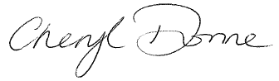
Approved by: | Date: | 25th October 2021
 | Name/Position: | Sarah Sheath, SOP Controller
 | Signature:
 | Date: | 26th October 2021

This Form will normally be reviewed every 3 years unless changes to the legislation require otherwise

Version History Log

This area should detail the version history for this document. It should detail the key elements of the changes to the versions.

Version | Date Implemented | Details of significant changes
1.0 | 18th March 2019
2.0 | 26th October 2021 | Minor changes relating to new labelling process

Introduction to
Pharmacy Clinical Trials –
Short course training package

Name ………………………………………………………………………….Date issued:……………

Job Role:……………………………………………….

Welcome to Pharmacy Clinical Trials,

This training and information package has been developed to provide an overview of clinical trials and the role pharmacy plays within research.

This package is suitable for pre-registration pharmacists and pharmacy technicians, work experience students, anyone who is new to pharmacy research or to anyone interested in pharmacy clinical trials. If you are to have a more comprehensive role within the pharmacy clinical trials team, then the Clinical Trials training package and competency pack must be completed.

What are clinical trials?

Clinical trials are a set of procedures in medical research and drug development that are conducted to allow safety (or more specifically, information about adverse drug reactions and adverse effects of other treatments) and efficacy data to be collected for health interventions (e.g., drugs, diagnostics, devices, therapy protocols). Clinical trials are an essential part of advancing healthcare and developing new therapies. They provide the basis of evidence-based medicine as well as the information needed by the regulatory authorities to allow drugs to become licensed. Clinical trials can only take place after satisfactory information has been gathered on the quality of the non-clinical safety, and MHRA/Health Authority/Ethics Committee approval is granted.

Examples of what a clinical trial may be designed to do:

- Assess the safety and effectiveness of a new medication or device on a specific kind of patient (e.g. patients who have been diagnosed with a specific disease)
- Assess the safety and effectiveness of a different dose of a medication than is commonly used (e.g. 10mg dose instead of 5mg dose)
- Assess the safety and effectiveness of an already marketed medication or device for a new indication, i.e. a disease for which the drug is not specifically approved for use
- Assess whether a new alternative medication is more effective for the patient’s condition compared to the existing medication.
- Compare the effectiveness in patients with a specific disease with two or more approved treatment (e.g. Treatment A vs. Treatment B)

A member of the pharmacy clinical trials team will take you through how we are notified of new trials, what work goes into setting up a study and how we maintain a study to a sponsors requirements and how we dispense a clinical trial.

Phase of clinical trials

There are different phases of clinical trials which are shown below:
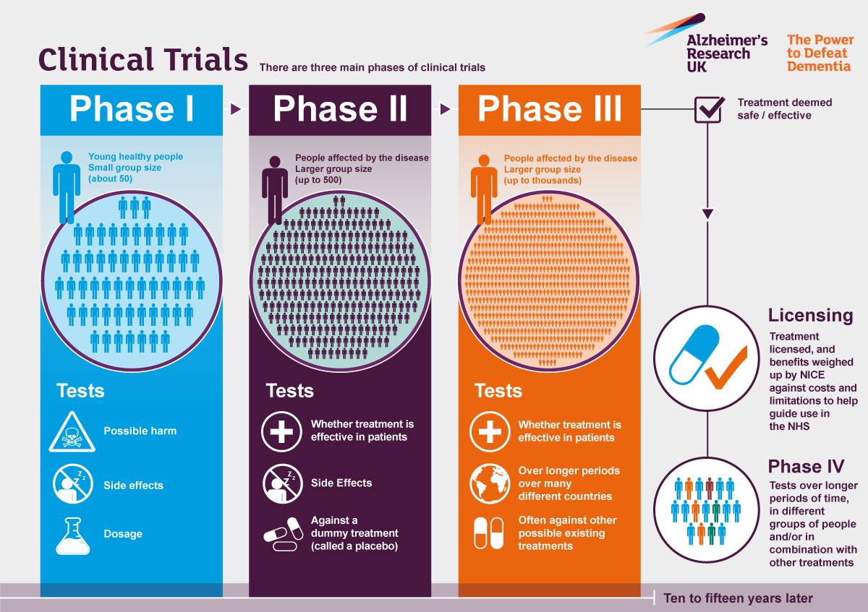

Shown below are the procedures that a new drug has to go through
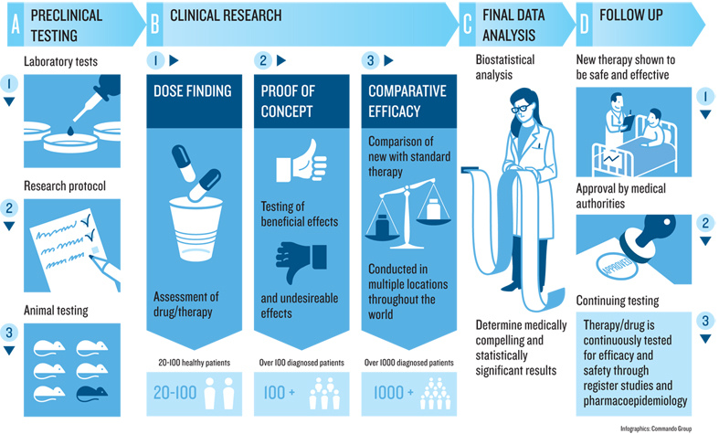

Good Clinical Practice (GCP)

The International Conference on Harmonisation of Technical Requirements for Registration of Pharmaceuticals for Human Use (ICH) Good Clinical Practice (GCP) is globally applicable guidance that sets the foundations for the conduct of all clinical research. All clinical trials conducted in the UK should follow GCP as this is a legal requirement under the UK Medicines for Human Use (Clinical Trials) regulations.
The cornerstones of GCP are the protection of the rights, safety and well-being of human subjects, and the provision of accurate and credible clinical trial data. In any clinical trial, the interests of an individual subject should always be considered more important than the interests of society.

GCP arose in response to various widely publicised drug disasters as well as unethical conduct in a number of clinical trials.
To give you a broad understanding or health research, log on to the National institute of health research website www.learn.nihr.ac.uk and complete the online GCP training.

Standard operating procedures (SOPs)

All the most up-to-date clinical trials SOPs are located on the Research and Development website. www.northyorksresearch.nhs.uk
When you are on the website you will be able to locate the pharmacy SOPs, forms and templates under the SOP and guidance heading on the right hand side of the home page. Pharmacy clinical trials SOP’s are also on QPulse if you wish to acknowledge that you have read and understood them.

Case study: The PROUD study

In the pharmacy clinical trials team we often get asked about the results of the studies we facilitate and what impact they have on the participants that take part in them.

One study that we facilitated as a Trust was the PROUD study. The videos linked below will help you understand how the PROUD study was conducted and how its results have had an impact on people’s lives.
https://vimeo.com/128625001

https://vimeo.com/214791866 (contains some strong language and sexual references)

Questions:

- Speak to a member of the team to find out what the term “blinding” means document your findings below:

- Research using the internet what the term “placebo” means document your findings below:

- List some studies that are currently running in clinical trials that are commercial studies and who their sponsors are:

- List some studies that are currently running in clinical trials that are non-commercial studies and who their sponsors are:

- Using the internet research about one of the first clinical trials ever conducted by Dr. James Lind in the search to find a remedy for scurvy. Describe how he conduct the trial below and his findings:

Importance of good clinical practice in drug trials

Watch the video of a stage one study found at: https://www.youtube.com/watch?v=a9_sX93RHOk

Think about all the points where you could see how the study could be improved to prevent the dangers from happening.

Tasks:

Ask a member of the clinical trials team to talk you through the tasks below, ensure you have read the relevant SOPs on the Research and Development website first.

Expression of Interest (EOI)

Ask the
Pharmacy clinical trials manager for an expression of interest (EOI) - these are new upcoming studies that either the research nurses or a consultant has expressed an interest in. It is usually at the very early stages and we have limited information on the study at this point. Using the relevant SOPs, forms and templates from the Research and Development website, have a go at interpreting what information you have been provided with to fill out the pharmacy clinical trials set up form pages 1 and 2. The pharmacy trials manager or senior clinical trials pharmacy technician will check your findings.

Access to Labels

All dispensing labels used with pharmacy clinical trials are found on the X:Drive in the study-specific folders, and must be accounted for using the ‘record of labels printed’ form located in section 2 of the Pharmacy site files. A member of the pharmacy clinical trials team will show you where to locate the master label for a chosen study. Ensure that you can print the study-specific labels and are set up on the label printers within Pharmacy Clinical Trials
JAC labels are also required when dispensing/issuing some stock used in Clinical Trials. Work with a member of Pharmacy Clinical Trials to check that your printer settings are correct for JAC and that you can print labels in the correct format.

File maintenance

File maintenance is an essential process which helps to ensure pharmacy site files are current and accurate.
Using the SOPs and forms on the Research and Development website, work alongside a member of the clinical trials team to perform file maintenance on one of the open studies.

