Pharmacy Trial Closedown Form
This form is to be used in conjunction with Pharm/S56

IT IS THE RESPONSIBILITY OF ALL USERS OF THIS SOP TO ENSURE THAT THE CORRECT VERSION IS BEING USED

All staff should regularly check the R&D Unit’s website and/or Q-Pulse for information relating to the implementation of new or revised versions. Staff must ensure that they are adequately trained in the new procedure and must make sure that all copies of superseded versions are promptly withdrawn from use unless notified otherwise by the SOP Controller.

The definitive versions of all R&D Unit SOPs appear online. If you are reading this in printed form check that the version number and date below is the most recent one as shown on the R&D Unit website: www.research.yorkhospitals.nhs.uk/sops-and-guidance-/ and/or Q-Pulse

SOP Reference: | Pharm/F87
Version Number: | 2.0
Author: | Rachel Spooner
Implementation date of current version: | 11th January 2021

Approved by: | Name/Position: | Poppy Cottrell-Howe, Pharmacy Clinical Trials Manager
Approved by: | Signature: | 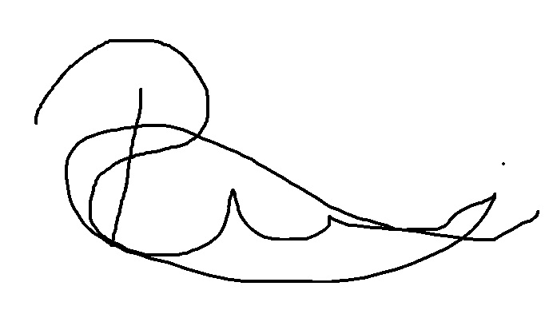
Approved by: | Date: | 9th December 2020
 | Name/Position: | Sarah Sheath, SOP Controller
 | Signature:
 | Date: | 14th December 2020

This SOP will normally be reviewed at least every 3 years unless changes to the legislation require otherwise

Version History Log

This area should detail the version history for this document. It should detail the key elements of the changes to the versions.

Version | Date Implemented | Details of significant changes
1.0 | 8th March 2019
2.0 | 11th January 2021 | Change of Author. Changes made to checks regarding labels and financial documents. Addition of the documents required to be filed at the end of the close down process.

Pharmacy Trial Closedown Form / Pharmacy site file archive ready
Name of Trial (short and long title)
EudraCT Number
R & D reference number
Principal Investigator
Sponsor
Hospital site
Speciality and Indication
Date of pharmacy close out visit (if applicable)
Date pharmacy site file requested to be prepared for archiving
By whom and their job role
Agreed date to have pharmacy site file prepared for archiving
Name of member of staff preparing pharmacy site file for closedown/archiving | Print:
 | Sign:
Pharmacy Clinical Trial Maintenance form has been completed prior to this form being filled out
Pharmacy file maintenance completed by | Print:
Pharmacy file maintenance completed by | Sign:
Date Pharmacy file maintenance completed | Date:

Read through the checklist overleaf - then liaise with the research team and sponsor regarding the information which is to be retained in the archiving of the pharmacy site file.

Task | Date and initial when reviewed/  completed | Comments or further actions required
Obtain and complete all relevant sections on the sponsor provided closedown documentation.
Attach a copy of the documentation to the back of this form.
Complete any actions from close out visit
Check to see if all of the patients’ prescriptions, accountability logs and any other dispensing records are fully signed and the relevant sections completed by the required member of staff.
Rectify any gaps, missing signatures or discrepancies.
Ensure all IMP is accounted for and seek approval for the destruction or return of any remaining IMP. For any remaining IMP that is destroyed, ensure a certificate of destruction is produced.
Remove any documentation not required for archiving e.g.:
- Completed accuracy/checking checklists
As instructed by the sponsor
Agree with the sponsors and research team if there is a requirement for there to be current and superseded protocols in the pharmacy site file as this is duplicated information which will be present in the main site file. If copies of protocols are not required to be retained by pharmacy compose a file note stating the agreement with the sponsor.
Agree with the sponsors and research team if there is a requirement for there to be amendment paperwork in the pharmacy site file as this is duplicated information which will be present in the main site file. If copies of amendment documentation are not required to be retained by pharmacy compose a file note stating the agreement with the sponsor.
Agree with the sponsors and research team if there is a requirement for there to be current and superseded investigator brochures in the pharmacy site file as this is duplicated information which will be present in the main site file. If copies of protocols are not required to be retained by pharmacy compose a file note stating the agreement with the sponsor.
Ensure all final financial invoices/transactions have been completed.
If applicable, any relevant financial documentation should be filed.
Check that no confidential information has been included and, if applicable, include a file note to indicate that all financial documents and invoices are present on the X:Drive.

If applicable obtain and file copies of all versions of the approved chemocare chart templates used for this study – these can be obtained from the oncology satellite team. Inform the oncology satellite team that they can archive the chemocare charts on the chemocare system.
Review the temperature graph data for the period from when IMP was received until it was destroyed or returned to sponsor. Add the data to the relevant section of the pharmacy site file or agree with the sponsor if this information is required to be retained in the pharmacy site file. If is not required provide a file note stating the information is stored centrally.
Add CV’s and GCP certificates for anyone that worked on the study
Ensure essential correspondence is filed into each relevant section of the pharmacy site file
If the sponsor has a specified format for the documentation, store as requested. If there is not a sponsor required format for filing, store as per local contents list and provide a copy of the contents list at the front.
Remove all documents from plastic wallets
Once complete, move the file to the ‘Prepared and ready for archive’ bay in the clinical trials dispensary.

Contact a member of the research team and inform them that the file is ready to collect and arrange a collection date. Once a collection date is arranged, handover the file and obtain a signature below from the member of staff accepting the Pharmacy site file.

Member of pharmacy clinical trials handing the pharmacy site file over:

Print:

Position:

Sign:

Date:

Member of research staff accepting the pharmacy site file:

Print:

Position:

Sign:

Date:

Once completed, copies of this form, the maintenance form, any other sponsor close down checklists, and a print-out of the permission given by the sponsor to archive must be filed at the front of the Pharmacy file. The original copies of these documents must be filed together in the ‘Closed studies – gone to archiving’ file stored in the Pharmacy clinical trials office.

Once completed and collected, the Pharmacy close down priorities spreadsheet on the X:Drive should be updated accordingly.

