AE/SAE Log
This Form must be used in conjunction with R&D/S19 and S05

IT IS THE RESPONSIBILITY OF ALL USERS OF THIS FORM TO ENSURE THAT THE CORRECT VERSION IS BEING USED

All staff should regularly check the R&D Unit’s website and/or Q-Pulse for information relating to the implementation of new or revised versions. Staff must ensure that they are adequately trained in the new procedure and must make sure that all copies of superseded versions are promptly withdrawn from use unless notified otherwise by the SOP Controller.

The definitive versions of all R&D Unit SOPs appear online. If you are reading this in printed form check that the version number and date below is the most recent one as shown on the R&D Unit website: /www.research.yorkhospitals.nhs.uk/sops-and-guidance-/ and/or Q-Pulse

Form Reference: | R&D/F46
Version Number: | 3.0
Author: | Mia Porteous
Implementation date of current version: | 9th February 2021

Approved by: | Name/Position: | Lydia Harris, Head of R&D
Approved by: | Signature: | 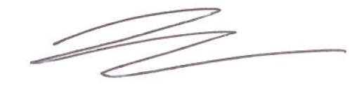
Approved by: | Date: | 12th January 2021
 | Name/Position: | Sarah Sheath, SOP Controller
 | Signature:
 | Date: | 12th January 2021

This SOP will normally be reviewed every 3 years unless changes to the legislation require otherwise

Version History Log

This area should detail the version history for this document. It should detail the key elements of the changes to the versions.

Version | Date implemented | Details of significant changes
1.0 | 22nd April 2013
2.0 | 15th August 2017 | Two year review, no changes required
3.0 | 9th February 2021 | Change of author. Change of link to R&D website. Addition of onset and resolution dates.

AE/SAE LOG

Study Title: | Chief/Principal Investigator:
R&D Reference Number/ IRAS number : | EUDRACT Number:

AE/SAE Reference number | Participant  ID | Date of Event Onset  dd-mm-yyyy | Date of Event Resolution  dd-mm-yyyy | Brief Description of Event | SUSAR  (Y/N) | Initials of individual making entry

