Clinical Trials Delivery Form

This form is to be used in conjunction with SOP Pharm/S101

IT IS THE RESPONSIBILITY OF ALL USERS OF THIS FORM TO ENSURE THAT THE CORRECT VERSION IS BEING USED

All staff should regularly check the R&D Unit’s website and/or Q-Pulse for information relating to the implementation of new or revised versions. Staff must ensure that they are adequately trained in the new procedure and must make sure that all copies of superseded versions are promptly withdrawn from use unless notified otherwise by the SOP Controller.

The definitive versions of all R&D Unit SOPs appear online. If you are reading this in printed form check that the version number and date below is the most recent one as shown on the R&D Unit website: www.research.yorkhospitals.nhs.uk/sops-and-guidance-/ and/or Q-Pulse

Form Reference: | Pharm/F92
Version Number: | 1.0
Author: | Poppy Cottrell-Howe
Implementation date of current version: | 8th April 2020

Approved by: | Name/Position: | Stuart Parkes  Deputy Chief Pharmacist
Approved by: | Signature: | 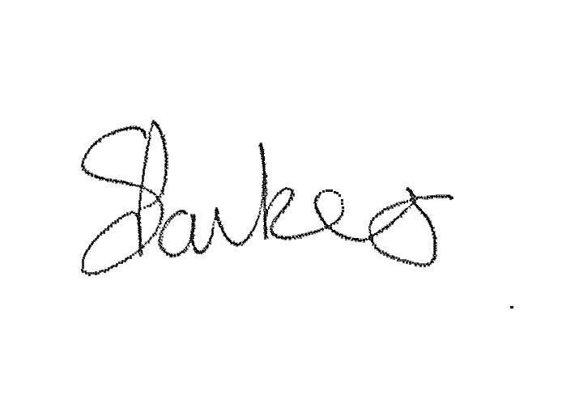
Approved by: | Date: | 7th April 2020
 | Name/Position: | Sarah Sheath, SOP Controller
 | Signature:
 | Date: | 7th April 2020

This Form will normally be reviewed every 3 years unless changes to the legislation require otherwise

Version History Log

This area should detail the version history for this document. It should detail the key elements of the changes to the versions.

Version | Date Implemented | Details of significant changes
1.0 | 8th April 2020

Clinical trials delivery from
TO BE COMPLETED BY PHARMACY
PATENT NAME: | PATIENT DATE OF BIRTH:
PATIENT ADDRESS: | PATIENT CONTACTED AND CONSENT GIVEN (tick✓ box to confirm)  STAFF MEMBER CONFRIMING CONSENT  NAME:  DATE:

If you encounter any problems during the delivery call the pharmacy clinical trials team on 01904 72 1684
TO BE COMPLETED BY MEMBER OF STAFF COLLECTING & DELIVERING
COLLECTED FROM PHARMACY |  | FURTHER DELIVERY INSTRUCTIONS | COLLECTED & DELIVERED BY  (print and sign name)
DATE | TIME
DELIVERED TO PATIENT |  | PATEINT DATE OF BIRTH CONFIRMED (tick✓ box to confirm)  ITEM(S) RECIVED BY PATEINT* (tick✓ box to confirm)  *A minimum distance of two meters must be maintained between the patient and staff member(s) at all times.
DATE | TIME

Return this completed form to pharmacy clinical trial

