Receipt of Code Break Envelopes Form

This form is to be used in conjunction with SOP Pharm/S54 – Managing Code Break Procedures

IT IS THE RESPONSIBILITY OF ALL USERS OF THIS FORM TO ENSURE THAT THE CORRECT VERSION IS BEING USED

All staff should regularly check the R&D Unit’s website and/or Q-Pulse for information relating to the implementation of new or revised versions. Staff must ensure that they are adequately trained in the new procedure and must make sure that all copies of superseded versions are promptly withdrawn from use unless notified otherwise by the SOP Controller.

The definitive versions of all R&D Unit SOPs appear online. If you are reading this in printed form check that the version number and date below is the most recent one as shown on the R&D Unit website: https://www.research.yorkhospitals.nhs.uk/sops-and-guidance-/ and/or Q-Pulse

Form Reference: | Pharm/F26
Version Number: | 5.0
Author: | Cheryl Donne
Implementation date of current version: | 3rd September 2020

Approved by: | Name/Position: | Poppy Cottrell-Howe, Pharmacy Clinical Trials Manager
Approved by: | Signature: | 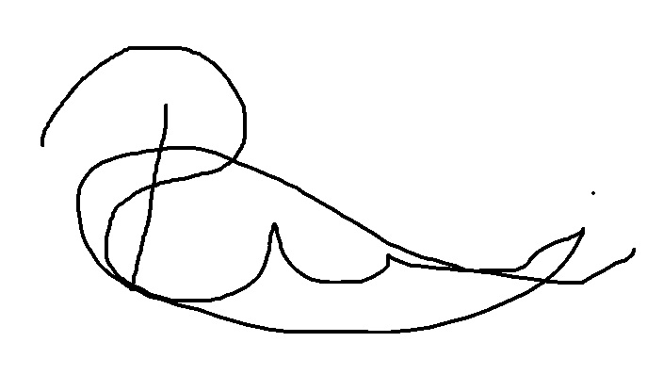
Approved by: | Date: | 6th August 2020
 | Name/Position: | Sarah Sheath, SOP Controller
 | Signature:
 | Date: | 6th August 2020

This Form will normally be reviewed every 3 years unless changes to the legislation require otherwise

Version History Log

This area should detail the version history for this document. It should detail the key elements of the changes to the versions.

Version | Date Implemented | Details of significant changes
1.0 | 1st February 2011
2.0 | 12th September 2013 | Removal of reference to the North and East Yorkshire R&D Alliance. Change of SOP Controller. Addition of hospital site prompt to enable the use of form at Scarborough hospital.
3.0 | 20th August 2015
4.0 | 31st July 2017 | Two year review. No changes required.
5.0 | 3rd September 2020 | Change of author. Change of link to R&D website.

Pharm/F26
receipt of code break envelopes form

(TO BE COMPLETED BY A MEMBER OF THE PHARMACY CLINICAL TRIALS TEAM UPON RECEIPT OF CODE BREAK ENVELOPES)

STUDY TITLE: |  | HOSPITAL SITE
PRINCIPAL INVESTIGATOR:
EUDRACT NUMBER:
PROTOCOL NUMBER:
R&D UNIT NUMBER:
NUMBER OF SETS OF ENVELOPES RECEIVED
RANDOMISATION NUMBERS
LOCATION
DATE RECEIVED
RECEIVED BY
SHIPMENT RECORD REFERENCE NUMBER

QUALITY CONTROL check

THE CODE BREAK ENVELOPES RECEIVED HAVE BEEN CHECKED AGAINST THE CRITERIA IN PHARM/S54 AND FOUND TO BE FIT FOR PURPOSE

SIGNATURE:
POSITION:
DATE:

