Distribution of Code Break Envelopes Form

This form is to be used in conjunction with SOP Pharm/S54 – Managing Code Break Procedures

IT IS THE RESPONSIBILITY OF ALL USERS OF THIS FORM TO ENSURE THAT THE CORRECT VERSION IS BEING USED

All staff should regularly check the R&D Unit’s website and/or Q-Pulse for information relating to the implementation of new or revised versions. Staff must ensure that they are adequately trained in the new procedure and must make sure that all copies of superseded versions are promptly withdrawn from use unless notified otherwise by the SOP Controller.

The definitive versions of all R&D Unit SOPs appear online. If you are reading this in printed form check that the version number and date below is the most recent one as shown on the R&D Unit website: https://www.research.yorkhospitals.nhs.uk/sops-and-guidance-/ and/or Q-Pulse

Form Reference: | Pharm/F27
Version Number: | 5.0
Author: | Cheryl Donne
Implementation date of current version: | 3rd September 2020

Approved by: | Name/Position: | Poppy Cottrell-Howe, Pharmacy Clinical Trials Manager
Approved by: | Signature: | 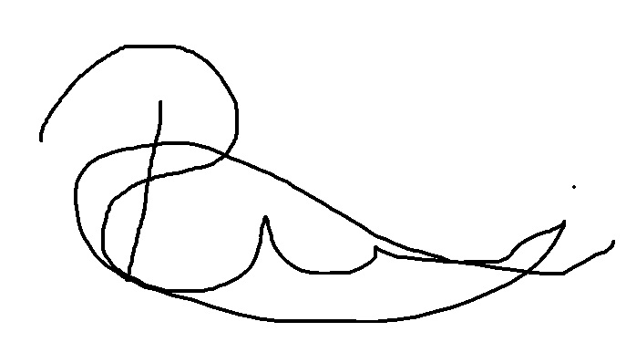
Approved by: | Date: | 6th August 2020
 | Name/Position: | Sarah Sheath, SOP Controller
 | Signature:
 | Date: | 6th August 2020

This Form will normally be reviewed every 3 years unless changes to the legislation require otherwise

Version History Log

This area should detail the version history for this document. It should detail the key elements of the changes to the versions.

Version | Date Implemented | Details of significant changes
1.0 | 1st February 2011
2.0 | 12th September 2013 | Removal of references to the North and East Yorkshire R&D Alliance. Change of SOP Controller. Addition of hospital site prompt to allow form to be used at Scarborough hospital also.
3.0 | 20th August 2015 | Minor changes only.
4.0 | 31st July 2017 | Two year review. No changes required.
5.0 | 3rd September 2020 | Change of author. Change of link to R&D website.

Pharm/F27
DISTRIBUTION OF CODE BREAK ENVELOPES FORM

(TO BE COMPLETED BY A MEMBER OF THE PHARMACY CLINICAL TRIALS TEAM WHEN DISTRIBUTING CODE BREAK ENVELOPES)

STUDY TITLE: |  |  | hospital site:
PRINCIPAL INVESTIGATOR:
EUDRACT NUMBER:
PROTOCOL NUMBER:
R&D UNIT NUMBER:
SET NUMBER OF CODE BREAK ENVELOPES:
RANDOMISATION NUMBERS:
ISSUED TO:
POSITION:
SIGNATURE:
DATE:
ISSUED BY:
DATE RETURNED:
RECEIVED BY:
POSITION:
NUMBERS OF ANY OPENED ENVELOPES:
REASON:

